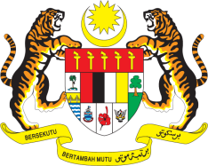

STATEMENT BY MALAYSIA
REVIEW OF CZECH REPUBLIC
42ND SESSION OF THE UPR WORKING GROUP
23 JANUARY – 3 FEBRUARY 2023

Malaysia acknowledges the various efforts undertaken by the Government of the Czech Republic, a fellow member at the HRC, since its last UPR review. We take note of several legislative interventions aiming at combating discrimination, enhancing gender equality, and addressing the needs of persons in vulnerable settings, among others.

- In the spirit of constructive engagement, Malaysia recommends the following:

3.1 Establish an adequately resourced social housing system and increase the availability of affordable housing, with particular attention to disadvantaged and marginalised groups, such as Roma, persons with disabilities and older persons;

3.2 Establish a national human rights institution in line with the Paris Principles;

3.3 Continue its efforts to combat all manifestations of hate speech, particularly against religious minorities, by strengthening legislative measures; and

3.4 Continue to implement the National Strategy for the Protection of Children's Rights (2021 to 2029) with an emphasis on Roma children and children with disabilities.

- We wish Czech Republic a successful review.

Thank you.

23 JANUARY 2023
GENEVA

