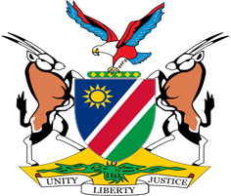

Statement by Jerry Mika, Deputy Permanent Representative, UPR of Sri Lanka , 01 February 2023

- Thank you, Mr. President,

- Namibia warmly welcomes the esteemed delegation of Sri Lanka, and we thank them for submitting their national report as well as for the additional information provided today on the measures taken since 2017 to improve the situation of human rights in Sri Lanka.

- Namibia notes with appreciation the specific legislative, policy and institutional measures adopted by Sri Lanka with the aim of fulfilling its obligations under international human rights law. We are particularly pleased to note that Sri Lanka continues to maintain a moratorium on the death penalty, and we encourage the Government to pursue further efforts towards the total abolition of the death penalty.

- Namibia offers the following two recommendations for consideration by Sri Lanka:

  - Ratify the Optional Protocol to the Convention on the Rights of Persons with Disabilities;

  - Ratify the International Labour Organisation’s Domestic Workers Convention (No. 189 of 2011).

- We wish the delegation of Sri Lanka a successful review.

- I thank you Mr. President.

