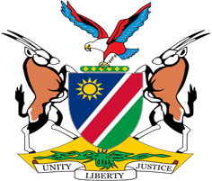

Statement by Jerry Mika, Deputy Permanent Representative, UPR of Pakistan, 31 January 2023

- Thank you, Mr. President,

- Namibia warmly welcomes the esteemed delegation of Japan, and we take this opportunity to salute Japan for its strong commitment to promote respect for human rights at both the national and international levels.

- Namibia commends Japan for the various measures taken during the period under review to, amongst others, protect the rights women, children and persons with disabilities. We are particularly pleased to note that Japan continues to pursue efforts aimed at eliminating discrimination against persons with disabilities.

- Namibia offers the following two recommendations for consideration by Japan:

  - Withdraw the reservation to Article 4 of the International Convention on the Elimination of All Forms of Racial Discrimination;

  - Take effective measures to prevent, combat and prohibit racial discrimination and hate speech, including by amending the Hate Speech Elimination Act, as recommended by the Committee on the Elimination of Racial Discrimination.

- We wish the delegation of Japan a successful review.

- I thank you Mr. President.

