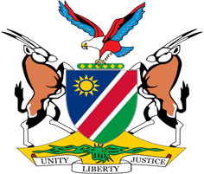

Statement by H.E. Julia Imene-Chanduru, Ambassador/Permanent Representative, UPR of Zambia, 30 January 2023

Speaking Time: 1 minute 15 seconds

- Thank you, Mr. President,

- Namibia warmly welcomes Honourable Mulambo Haimbe, Minister of Justice of the Republic of Zambia, and his delegation to the fourth cycle Universal Periodic Review. We thank them for submitting a comprehensive national report which clearly outlines the measures taken during the period under review to improve the enjoyment of human rights by all persons on its territory.

- Notwithstanding the challenges induced by the global economic crunch and the COVID-19 pandemic, Namibia is, among other things, pleased to note that Zambia continues to pursue efforts aimed at the progressive realization of economic, social and cultural rights, including the right to social security.

- In the spirit of constructive engagement, Namibia offers the following two recommendations for consideration by Zambia:

  - Guarantee the independence of the National Human Rights Commission and ensure its proper functioning in accordance with the Paris Principles;

  - Take effective measures to protect persons with albinism from violence and discrimination, including by guaranteeing their right to life.

- While wishing the Zambian delegation a very successful review, we urge the international community to positively respond to the appeal by Zambia for financial and technical assistance towards the further enhancement of human rights in Zambia.

- Thank you, Mr. President.

