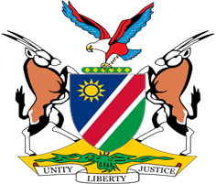

Statement by H.E. Julia Imene-Chanduru, Ambassador/Permanent Representative, UPR of Switzerland, 27 January 2023

Speaking Time: 1 minute

- Thank you, Mr. President,

- Namibia welcomes the distinguished delegation of our host Country, Switzerland, and thank them for the comprehensive national report they have prepared and presented today.

- Namibia commends Switzerland for its strong commitment to promote respect for human rights at both the national and international levels. We are particularly pleased to note that Switzerland in the conduct of its foreign relations, among other things, pays special attention to issues of freedom of expression, the death penalty and the rights of minorities.

- While appreciating the efforts of Switzerland to advance respect for human rights, Namibia offers the following two recommendations for consideration by Switzerland:

  - Withdraw the reservations to Article 2 (1) (a) and Article 4 of the International Convention on the Elimination of All Forms of Racial Discrimination;

  - Take effective measures to prevent and combat racist hate speech, including by ensuring that perpetrators are punished.

- Finally, we wish Switzerland a very successful review.

- Thank you, Mr. President.

