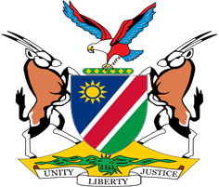

Statement by Jerry Mika, Deputy Permanent Representative, UPR of the Republic of Korea, 26 January 2023

Speaking Time: 1 minute 15 seconds

- Namibia welcomes the distinguished delegation of the Republic of Korea to this UPR Session and thank them for submitting a comprehensive national report as well as for the additional information provided today.
- Namibia notes with appreciation the significant strides made by the Republic of Korea to advance respect for human rights and for its commitment to sustainable development. We particularly applaud the Korean government for adopting a human rights-based approach to international development cooperation. The introduction of human rights education as a school subject in 2018, also finds our admiration.
- Namibia offers the following two recommendations for consideration by the Republic of Korea:
  - Ratify the Optional Protocol to the Convention on the Rights of Persons with Disabilities;
  - Withdraw the reservation to Article 16 (1) (g) of the Convention on the Elimination of All Forms of Discrimination against Women.
- We wish the Republic of Korea all the best during their review.

