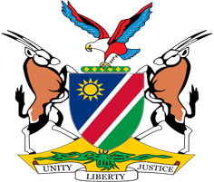

Statement by Jerry Mika, Deputy Permanent Representative UPR of Benin, 26 January 2023

- Thank you, Mr. President,

- Namibia warmly welcomes the esteemed delegation of Benin and thank them for their commitment to the UPR process.

- We note with appreciation the reforms adopted by Benin to advance respect for human rights during the period under review. We particularly commend Benin for its accession to a number of international treaties, including the optional protocol to the Convention on the Elimination of All Forms of Discrimination against Women.

- We encourage Benin to further pursue national efforts towards the effective implementation of these international instruments.

- In the spirit of constructive engagement, we offer the following two recommendations for consideration by Benin:

  - Guarantee the independence of the National Human Rights Commission and enable it to effectively exercise its mandate through the provision of adequate financial and human resources.

  - Take effective measures to prevent, suppress, and punish trafficking in persons.

- We wish the delegation of Benin a successful review.

