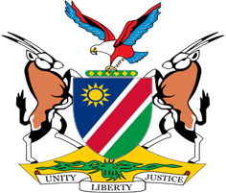

Statement by Jerry Mika, Deputy Permanent Representative UPR of Gabon, 24 January 2023

- Thank you, Mr. President,

- Namibia welcomes this opportunity to have a constructive dialogue with the esteemed delegation of Gabon on the human rights impacting measures taken by Gabon since its last review in 2017.

- Namibia, amongst other things, applauds Gabon for adopting legislative measures aimed at eliminating violence against women and ensuring equality men and women in Gabon. We also note with appreciation the ongoing efforts of Gabon to strengthen the mandate of the National Commission on Human Rights.

- While acknowledging the progress made, we offer the following two recommendations for consideration by Gabon:

  - Guarantee the freedom to seek, receive and impart information, including by developing and adopting a law on access to information;
  - Strengthen legislative and institutional frameworks to prevent, suppress, and punish trafficking in persons.

- We wish the delegation of Gabon a successful review.

- I thank you, Mr. President.

