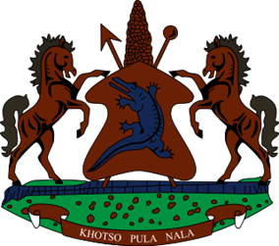
STATEMENT BY THE KINGDOM OF LESOTHO DURING THE 4TH UPR REVIEW OF ZAMBIA

30 JANUARY, 2023

Thank you, Mr. President,
Lesotho welcomes the distinguished delegation of Zambia to the 4th UPR cycle and thanks them for their comprehensive Report and presentation. We commend them for the positive developments achieved since their last review, notably in strengthening public policies to address economic and social challenges, including through the adoption of programmes aimed at improving equitable access to safe drinking water. We specifically welcome the efforts in developing the National Strategy on Financial Education, which aims to equip the Zambian population with skills to secure positive financial outcomes for themselves.
In spite of the positive developments noted, Lesotho wishes to make the following constructive recommendations for consideration by Zambia: 1. To bolster efforts to undertake legal reforms in order to address backlog of criminal cases. 2. To speed up efforts to pass the Environmental Management (Amendment) Bill into law in order to protect people’s human rights within the proximity of mining areas. 3. Continue efforts to reduce the teacher-pupil ratio in schools as well as increasing infrastructure to cater for increased school enrolments.
Lesotho wishes Zambia every success with the implementation of the recommendations emanating from this review.
I thank you

