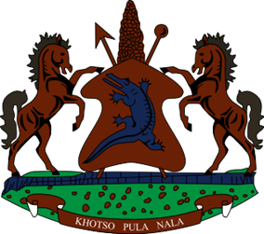
STATEMENT BY THE KINGDOM OF LESOTHO DURING THE 4TH UPR REVIEW OF BENIN

26 JANUARY, 2023

Thank you, Mr. President,
Lesotho welcomes the distinguished delegation of Benin and thanks them for the presentation of their Report. Lesotho welcomes the ratification of the Optional Protocol to the Convention on the Rights of the Child on a communications procedure. We also acknowledge efforts made in safeguarding the right to health of vulnerable populations by increasing the budget of the Health-Care Fund for the Poor and by proving free psychosocial and medical care for obstetric fistula.
Despite the progress that has been made, Lesotho is aware of the challenges that Benin has been grappling with, in respect to the fulfillment of the human rights of its people and therefore in a constructive spirit, Lesotho recommends that: 1. Benin to investigate acts of violence against women and girls, including domestic violence. 2. To redouble efforts to train and capacitate defence and security forces on the excessive use of force and on maintaining order during demonstrations. 3. Step up work to improve Prison conditions, especially overcrowding, sanitary conditions and access to food and medical supplies.
Lesotho wishes Benin every success with the implementation of the recommendations emanating from this review.

I thank you

