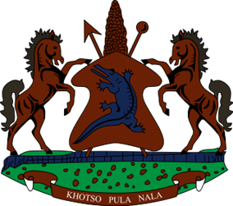
STATEMENT BY THE KINGDOM OF LESOTHO DURING THE 4TH UPR REVIEW OF GHANA

24 JANUARY, 2023

Thank you, Mr. President,
Lesotho welcomes the distinguished delegation of Ghana to the working Group and thanks them for the presentation of their Report. My delegation is cognizant of the measures put in place by Ghana to promote and protect human rights of its citizens. Lesotho applauds the government of Ghana for its efforts to combat human trafficking, by dedicating over a hundred thousand US dollars to the Ministry of Gender, Children and Social Protection, with a view to protecting victims trafficking. We welcome the development of policies aimed at improving Reproductive, Maternal Health and Nutrition.
In the spirit of constructive dialogue, Lesotho has the following recommendations for consideration by Ghana: 1. To develop specific legislation protecting women's right to work, non-discrimination, sex and gender discrimination, and the right to found a family. 2. To speed up efforts to establish a Mental Health Levy that would fund activities involving mental health. 3. To prohibit all forms of violence against children in all settings, including corporal punishment, harmful traditional practices, as well as honour crimes.
Finally, we wish Ghana every success with this UPR cycle.

