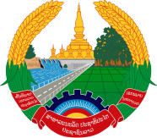
Statement by the delegation of the Permanent Mission of the Lao PDR to the United Nations Office and other International Organizations in Geneva
At the 42nd Session of the UPR Working Group
Geneva, 23 January-3 February 2023
_________

Review of the Pakistan, 30 January 2023 (09:00-12:30 hours)

- Mr. President,

- The Lao PDR warmly welcomes and thanks the delegation of Pakistan for the national report presented today.

- My delegation commends Pakistan for the progress made in the promotion and protection of the rights of women and children through the adoption of national legislations and policies framework, including the establishment of the National Commission on the rights of Child.

- The Lao PDR would like to offer two recommendations:

- Continue working with the working group on the right to development to strengthen international norms on development;

- Engage with the international community for the recovery and restoration of people affected by the floods.

- I wish Pakistan a success in this UPR.

- I thank you, Mr. President.

