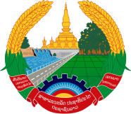
Statement by the delegation of the Permanent Mission of the Lao PDR to the United Nations Office and other International Organizations in Geneva
At the 42nd Session of the UPR Working Group
Geneva, 23 January-3 February 2023
_________

Review of the Republic of Korea, 26 January 2023 (14:30-18:00 hours)

- Mr. President,

- The Lao PDR warmly welcomes and thanks the delegation of Korea for the comprehensive report.

- My delegation commends the Republic of Korea for its active engagement with the UN human rights mechanisms, as well as its contribution to the international development cooperation framework. We appreciate the progress made in promoting and protecting the rights of vulnerable groups.

- The Lao PDR would like to offer two recommendations:

- Strengthen the implementation of national plans for preventing violence against women and promoting gender equality.

- Continue efforts towards improving welfare and living conditions of the elderly.

- I wish the Republic of Korea every success in this UPR cycle.

- I thank you, Mr. President.

