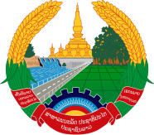
Statement by the delegation of the Permanent Mission of the Lao PDR to the United Nations Office and other International Organizations in Geneva
At the 42nd Session of the UPR Working Group
Geneva, 23 January-3 February 2023
_________

Review of the Sri Lanka, 1 February 2023 (09:00-12:30 hours)

- Mr. President,

- The Lao PDR warmly welcomes the delegation of Sri Lanka and thanks for the national report.

- My delegation commends Sri Lanka for its strong commitment to promote national reconciliation among different communities, and the progress it had been made on gender equality and women’s empowerment through the development of national laws and policies framework.

- In the constructive spirit, the Lao PDR would like to offer two recommendations:

- Intensify efforts towards achieving poverty reduction and sustainable development goals;

- Further strengthen measures to ensure equal access to education for all children, including children with disabilities and children in rural areas.

- We wish Sri Lanka a very successful UPR review.

- I thank you, Mr. President.

