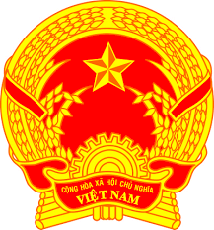
NATIONAL STATEMENT OF VIET NAM
42nd Session of the UPR Working Group
Review of Japan
(31 January 2023, 09:00 – 12:30)

Delivered by Ms. LE Thi Tuyet Mai,
Ambassador, Permanent Representative of Viet Nam to the UNOG

Mister President,
Viet Nam welcomes the delegation of Japan and commends its strong commitments and efforts undertaken as well as progress made in the promotion and protection of human rights both domestically and internationally.
We appreciate Japan’s effective implementation of recommendations from the previous UPR.
In the spirit of constructive dialogue, Viet Nam makes two recommendations to Japan:
- Continue to carry out human rights awareness-raising activities to deepen public understanding of human rights and to promote the principle of respect for human rights ;
- Better address societal discrimination against migrants and ensure their equal access to housing, education, health care and employment opportunities, without discrimination.
We wish Japan a success UPR.
I thank you, Mister President.

