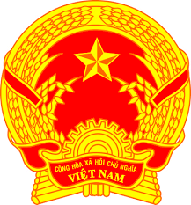
Statement of the Socialist Republic of Viet Nam
42nd Session of the UPR Working Group
Review of Zambia
(Geneva, 30 January 2023)

Time: 1 minute and 15 seconds
Mister President,
Viet Nam welcomes the delegation of Zambia and thanks them for the national UPR report.
We applaud a number of measures taken by Zambia to carry out recommendations since the adoption of its third UPR report, especially the establishment of National Mechanism for Implementation Reporting and Follow-up.
In a spirit of constructive dialogue, we wish to recommend to Zambia:
First, continue efforts to address the problem of discrimination based on gender and violence against women and girls including child marriage.
Second, continue efforts to promote economic and social sustainable development to improve people’s standard of living and lay a solid foundation for the enjoyment of all human rights.
In conclusion, Viet Nam wishes Zambia every success with this UPR cycle.
Thank you, Mister President./.

