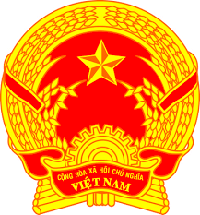
Statement of the Socialist Republic of Viet Nam
42nd Session of the UPR Working Group
Review of Pakistan
(Geneva, 30 January 2023)

Time: 55 seconds
Mister President,
Viet Nam welcomes and thanks the delegation of Pakistan for its national UPR report.
We appreciate the measures taken by Pakistan to ensure the realization and enjoyment of basic civil, political, economic, social and cultural rights of its citizens
In a spirit of constructive dialogue, Viet Nam has 2 recommendations to Pakistan:
First, continue its efforts to reduce the poverty and promote economic and social sustainable development.
Second, implement further programs to create jobs to ensure the realization of the right to work.
Viet Nam wishes Pakistan a successful review.
Thank you, Mister President./.

