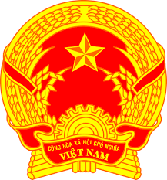
NATIONAL STATEMENT OF VIET NAM
42nd Session of the UPR Working Group
Review of Switzerland
(27 January 2023, 09:00 – 12:30)

Delivered by Mr. CUNG Duc Han,
Deputy Permanent Representative of Viet Nam to the UNOG

Mister President,
Viet Nam welcomes the delegation of Switzerland to the UPR and commends its measures taken to implement UPR recommendations and translate them into progress towards the achievement of the Sustainable Development Goals.
In a spirit of open dialogue, Viet Nam offers the following recommendations:
- Strengthen women’s economic empowerment in the framework of implementing the Equality Strategy 2030;
- Continue to promote the integration of marginalized and disadvantaged children and improve their access to quality public education;
- Better ensure an adequate standard of living for persons living in its territory through harmonized social assistance systems across the cantons and common minimum criteria for levels of welfare benefits.
We wish Switzerland all success for its review.
I thank you, Mister President.

