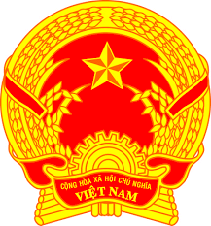
NATIONAL STATEMENT OF VIET NAM
42nd Session of the UPR Working Group
Review of the Republic of Korea
(26 January 2023, 14:30 – 18:00)

Delivered by Ms. LE Thi Tuyet Mai,
Ambassador, Permanent Representative of Viet Nam to the UNOG

Mister President,
Viet Nam welcomes the delegation of the Republic of Korea and commends its remarkable progress in ensuring the enjoyment of human rights since the last UPR review.
We applaud the Republic of Korea’ efforts in increasing female representation, respecting cultural diversity and supporting marriage immigrants and multicultural families.
In a spirit of constructive dialogue, Viet Nam makes three recommendations to the Republic of Korea:
1. Continue implementing policies and measures for eliminating discrimination against women and to promote gender equality;
2. Better protect labour rights of foreign workers and combat discrimination between national and foreign workers;
3. Conduct more multicultural understanding education for youth, public officials, and educators to prevent social discrimination and prejudice against multicultural families and respect cultural diversity.
We wish the Republic of Korea a successful UPR.
I thank you, Mister President.

