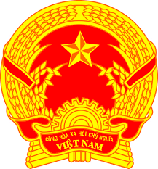
Statement of the Socialist Republic of Viet Nam
42nd Session of the UPR Working Group
Review of Benin
(Geneva, 26 January 2023)

Time: 1 minute and 10 seconds
Mister President,
Viet Nam welcomes and thanks the delegation of Benin for its national UPR report. We wish Benin every success with this UPR cycle.
We welcome Benin’s inclusive and transparent reform as well as its efforts to strengthen the legislative, institutional and policy framework for the promotion and protection of human rights.
In a spirit of constructive dialogue, may Viet Nam make the following recommendations to Benin:
First, continue to take steps to promote the rights of women in the political, economic, social, legal and cultural spheres, in both the public and private sectors, and to combat all forms of discrimination and violence against women.
Second, continue efforts in the fight against hunger in order to achieve food security.
Thank you, Mister President./.

