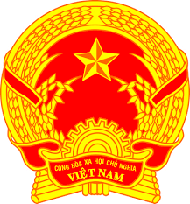
NATIONAL STATEMENT OF VIET NAM
42nd Session of the UPR Working Group
Review of Guatemala
(25 January 2023, 14:30 – 18:00)

Mister President,
Viet Nam welcomes the delegation from Guatemala to this review and expresses our appreciation for today’s national UPR presentation.
We commend Guatemala for the achievements in the review period. We also acknowledge the establishment in 2020 of the Presidential Commission for Peace and Human Rights to better fulfill commitments under the Peace Agreements and to coordinate the effective enjoyment and protection of human rights in Guatemala.
My delegation further recognizes the effective measures that Guatemala has taken to protect its population in response to the COVID-19 pandemic and highlights Guatemala’s inclusive public policy for youth.
In a spirit of constructive dialogue, Viet Nam makes the following recommendations to Guatemala:
- Take effective measures to address the disproportionate levels of poverty among women as well as their persistent economic and social inequality;
- Streamline relevant policies on minimum age of employment and compulsory education to expand educational opportunities for children from all backgrounds;
- Increase budget allocation to programmes for child and maternal health and mortality.
We wish the delegation of Guatemala a successful UPR.
I thank you, Mister President.

