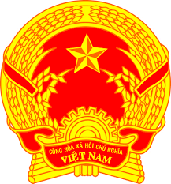
Statement of the Socialist Republic of Viet Nam
42nd Session of the UPR Working Group
Review of Ghana
(Geneva, 24 January 2023)

Time: 1 minute and 05 seconds
Mister President,
Viet Nam welcomes and thanks the delegation of Ghana for the comprehensive presentation of the national UPR report.
We welcome Ghana’s establishment of the National Mechanism for Reporting and Follow-ups and achievements in the implementation of Ghana’s obligations under international human rights treaties to which Ghana is a party.
In a spirit of constructive dialogue, Viet Nam makes two recommendations to Ghana:
First, continue efforts to guarantee access to education and educational resources to all children, and to ensure that children with special needs and disabilities are at the forefront of these efforts.
Second, continue efforts to combat discrimination against women and end all forms of violence against women, including domestic violence.
In conclusion, Viet Nam wishes Ghana every success with this UPR cycle.
Thank you, Mister President./.

