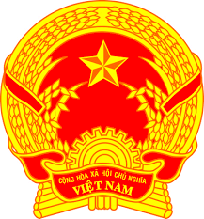
NATIONAL STATEMENT OF VIET NAM
42nd Session of the UPR Working Group
Review of Gabon
(24 January 2023, 09:00 – 12:30)

Delivered by Mr. CUNG Duc Han,
Deputy Permanent Representative of Viet Nam

Mister President,
Viet Nam warmly welcomes the distinguished delegation of Gabon and its comprehensive presentation of the national UPR report.
We commend Gabon’s commitment to the UPR Process and congratulate Gabon on the effective implementation of the 143 recommendations accepted during the third UPR cycle despite many resource constraints and challenges, which have been made worse by the COVID-19 pandemic.
Viet Nam recognizes Gabon’s priorities and efforts in strengthening national human rights bodies, protecting the rights of vulnerable groups and aligning national legislation with international instruments.
At this UPR, Viet Nam has the following recommendations to Gabon:
- Implement a more comprehensive strategy on inclusive education, including for children with disabilities and tertiary education for girls.
- Enhance social assistance and protection programmes to the most vulnerable and disadvantaged groups, particularly minorities, persons with disabilities, the poor and women in rural areas.
In conclusion, we wish the delegation of Gabon a successful review.
I thank you, Mister President./.

