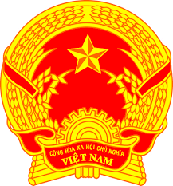
Statement of the Socialist Republic of Viet Nam
42nd Session of the UPR Working Group
Review of Argentina
(Geneva, 23 January 2023)

Delivered by Ms. LE Thi Tuyet Mai,
Ambassador, Permanent Representative of Viet Nam to the UNOG

Mister President,
Viet Nam welcomes and thanks the delegation of Argentina for the comprehensive presentation of the national UPR report.
We welcome Argentina’s achievements in the review period, particularly the establishment of the Ministry of Women, Gender and Diversity with its work in prioritizing women’s rights, gender and diversity, and the implementation of various initiatives in preventing gender-based violence as well as providing support to victims of such violence.
In a spirit of constructive dialogue, Viet Nam makes two recommendations to Argentina:
First, continue efforts to eradicate poverty in order to better protect, support and assist all people living below the poverty line.
Second, continue efforts to improve prison conditions and guarantee the rights of prisoners.
In conclusion, Viet Nam wishes Argentina every success with this UPR cycle.
Thank you, Mister President./.

