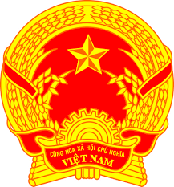
NATIONAL STATEMENT OF VIET NAM
42nd Session of the UPR Working Group
Review of Czechia
(23 January 2023, 09:00 – 12:30)

Delivered by Ms. LE Thi Tuyet Mai,
Ambassador, Permanent Representative of Viet Nam to the UNOG

Mister President,
Viet Nam warmly welcomes the delegation of Czechia and thanks them for their national UPR report.
First, we congratulate Czechia for being elected as the President of the Human Rights Council for 2023 and welcome its achievements during the review period, particularly the adoption by the Czech Government of the Strategic Framework Czech Republic 2030 that emphasized long-term sustainable development priorities and quality of life for its people.
In a spirit of constructive dialogue and cooperation, we make two recommendations to Czechia:
One, enhance its gender equality programmes for more equal representation of and opportunities for women in politics, decision-making positions, the labour market, business, and various other sectors.
Two, undertake steps to facilitate the transition of workers from the informal sector to the formal sector of the economy and ensure that they are covered by labour laws and have access to social protection.
In conclusion, we wish Czechia a successful UPR.
I thank you, Mister President./.

