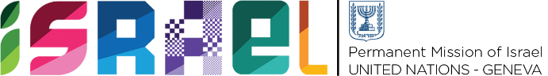 | Check against delivery  1 min

Statement on behalf of the State of Israel
UPR WORKING GROUP – 42nd SESSION
27 January 2023

Review of Switzerland

Israel welcomes the delegation of Switzerland to the UPR and would like to thank it for its National Report.
Israel welcomes that a number of legislative amendments aimed at improving protection for victims of domestic violence entered into force in July 2020.
Israel also commends Switzerland for steps taken in order to fight growing racism and antisemitism, especially the Federal Council’s decision to participate in covering security expenses of Jewish communities and institutions.
Israel would like to recommend that Switzerland:
- Continue improving coordination of efforts to fight racism and antisemitism, adopt the IHRA definition as an important working tool, enhance teaching about the Holocaust in Swiss schools and promote restrictions on use and display of Nazi symbols in public sphere.
- Take further measures aimed at eliminating all forms of violence against women, including domestic violence and femicide.
- Implement anti-bullying campaigns in schools addressing all forms of bullying, including that based on sexual orientation and gender identity (SOGI).
I thank you.

