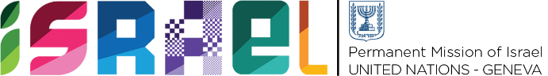 | Check against delivery  1 min 15 sec

Statement on behalf of the State of Israel
UPR WORKING GROUP – 42nd SESSION
26 January 2023

Review of Republic of Korea

Israel welcomes the delegation of the Republic of Korea to the UPR and would like to thank it for its National Report.
Israel commends the Republic of Korea for progress made regarding the recommendation Israel made in the 3rd cycle of the UPR concerning the working conditions of non-regular workers. Israel also commends the Republic of Korea for taking further measures to improve the rights of persons with disabilities. In addition, Israel is encouraged by steps taken by the government to tackle violence against women; however, Israel is concerned about a number of reports of sexual violence within the armed forces.
In this context, Israel would like to recommend the Republic of Korea:
- Review the prevention and protection mechanisms on sexual violence in the military
- Strengthen legislative measures and financial support to enhance the access of persons with disabilities to public transportation and public facilities
Israel would like to recommend further that the Republic of Korea:
- Continue to take measures to tackle all forms of discrimination, including on the grounds of sexual orientation and gender identity.
I thank you.

