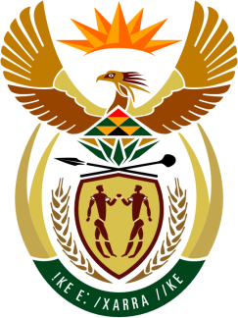

SOUTH AFRICAN PERMANENT MISSION
TO THE UNITED NATIONS
AND OTHER INTERNATIONAL ORGANISATIONS

42ND SESSION OF THE WORKING GROUP ON THE
UNIVERSAL PERIODIC REVIEW

Review of PAKISTAN

30 JANUARY 2023

(70 Seconds)

speaker no: 51

Check against delivery

Mr. President,

South Africa welcomes the distinguished delegation of Pakistan to this UPR Session and wishes the country a successful review.

South Africa commends Pakistan for the efforts undertaken towards the domestication of international human rights instruments in accordance with the country’s National Action on Human Rights, including the adoption of the 2022 amendment to the Protection Against Harassment of Women at the Workplace Act. South Africa similarly welcomes the country’s 2022 National Gender Policy Framework, which will no doubt go a long way in advancing the national gender agenda.

South Africa wishes to make the following recommendations:

- Accelerate efforts towards the withdrawal of the declaration made upon accession to the Convention on the Elimination of All Forms of Discrimination against Women and ratify the Optional Protocol in this regard.
- Enact the 2021 Domestic Violence (Prevention and Protection) Bill.
- Undertake measures to remove any barriers that impede access to sexual and reproductive health for adolescents’.
- Review the legislation related to prisons to ensure that it accords with the United Nations Standard Minimum Rules for the Treatment of Prisoners (the Nelson Mandela Rules).

I thank you

