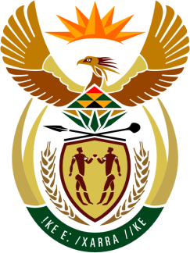

SOUTH AFRICAN PERMANENT MISSION
TO THE UNITED NATIONS
AND OTHER INTERNATIONAL ORGANISATIONS

42ND SESSION OF THE WORKING GROUP ON THE
UNIVERSAL PERIODIC REVIEW

Review of ZAMBIA AT 14:30-18:00

30 JANUARY 2023

(75 Seconds)

speaker no:65

Check against delivery

Mr. President,

South Africa welcomes the distinguished delegation of Zambia to this UPR Session and wishes the country a successful review.

South Africa welcomes Zambia’s enactment of the Children’s Code Act No. 12 of 2022, which prohibits subjecting children to economic exploitation or any work that is hazardous or likely to interfere with the child’s education, physical or mental health, spiritual, moral, emotional or social development.

South Africa recommends that Zambia:
- Assess the impact of the National Strategy on Ending Child Marriage in Zambia 2016 – 2021 and undertake follow up measures and increase its efforts to address the root causes of early marriages and maintain girls in the education system, and suggests that Zambia to adopt the ‘Southern African Development Community (SADC) Model Law to End Child Marriage,’
- Continue strengthening the frameworks for the coordination of social protection policies focused on adolescents, to facilitate safe and productive transitions to adulthood in lower- and middle-income families.
- Develop or strengthen existing parenting programs with messages and actions aimed at engaging the parents in reducing the child labour and prioritise children’s education
- Take urgent actions to combat physical attacks and mutilations, killings, discrimination persons with albinism, including their limited access to health care and education.
I thank you.

