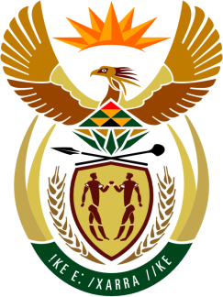

SOUTH AFRICAN PERMANENT MISSION

42Nd SESSION OF THE WORKING GROUP ON THE
UNIVERSAL PERIODIC REVIEW

Review of Guatemala

25 JANUARY 2023

14H30-18H00

(60 secONDS)

PALAIS DES NATIONS, GENEVA

Check against delivery

Mr. President,

South Africa welcomes the distinguished delegation of Guatemala to this UPR Session and wishes the country a successful review.

Our delegation welcomes initiatives by the Government of Guatemala towards the promotion and protection of the rights of children, which include the school meals programmes, the establishment of the courts for the protection of children and adolescents and the school insurance scheme.

In order to ensure progress in promoting and protecting human rights, South Africa recommends that Guatemala:

- Consider reviewing measures contained in the legislative agenda of the Congress which hinder the promotion and protection of several human rights including the rights of vulnerable groups namely women, LGBTQI+ persons and indigenous people,

- Harmonise the provisions of the Criminal Code relating to the age of sexual consent for both boys and girls,

- Ensure unimpeded access to quality sexual and reproductive health services and comprehensive sex education for all,

- Enhance efforts to protect Indigenous Peoples against forced evictions from their territories.
I thank you.

