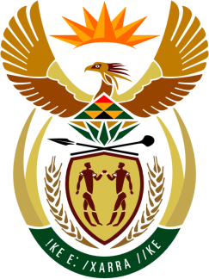

SOUTH AFRICAN PERMANENT MISSION
TO THE UNITED NATIONS
AND OTHER INTERNATIONAL ORGANISATIONS

42ND SESSION OF THE WORKING GROUP ON THE
UNIVERSAL PERIODIC REVIEW

GHANA

23 JANUARY 2023 at 14:30-18:00

(65 Seconds)

speaker no:35

Check against delivery

Mr. President,

South Africa welcomes the distinguished delegation of Ghana to this UPR Session and wishes the country a successful review.

South Africa commends Ghana on the introduction of the Ghana School Feeding Programme (GSFP), in line with SDGs 1 and 2, which provides daily meals to beneficiary pupils in all districts of the country, which has ensured a high level of school enrolment.

South Africa respectfully makes the following recommendations:

- Publicly recognize the legitimacy of the work of all human rights defenders, including by developing and disseminating public awareness campaigns about the key role all human rights defenders play in the defence of human rights with the aim of countering discrimination, misinformation and hostility towards human rights defenders.
- Accelerate the adoption and implementation of laws prohibiting harmful practices against women and girls, including trokosi, female genital mutilation, early and forced marriage and accusations of witchcraft as well as guaranteeing the protection and rehabilitation of victims.
- Include human rights guarantees in the Mining Bill, the Petroleum (Exploration, Development and Production) Bill, the Energy Bill as well as in related policies and regulations especially in relation to control of illegal mining activities and integration of community rights.
I thank you

