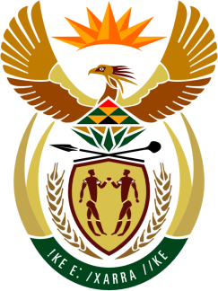

SOUTH AFRICAN PERMANENT MISSION
TO THE UNITED NATIONS
AND OTHER INTERNATIONAL ORGANISATIONS

42ND SESSION OF THE WORKING GROUP ON THE
UNIVERSAL PERIODIC REVIEW

Review of gABON

24 JANUARY 2023 AT 09:00-12:30

(70 Seconds)

speaker no: 9

Check against delivery

Mr. President,

South Africa welcomes the distinguished delegation of Gabon to this UPR Session and wishes the country a successful review.

Given the indivisibility of all human rights, South Africa commends Gabon for introducing Constitutional reforms that introduced positive discrimination in favour of women to secure equal access to elected office and positions of responsibility in political and professional life for women and men (art. 1 (24)), and the extension of the provisions of article 6, on equality of access to elected office, to young people and persons with disabilities.

South Africa recommends that Gabon:

- Ratify the Optional Protocol to the ICCPR (International Covenant on Civil and Political Rights) and the Protocol to the African Charter on Human and People’s Rights on the Rights of Women in Africa;
- Implement the ICPD25 commitment (International Conference on Population and Development) to tackle maternal mortality by extending the maternal health policy; and
- Allocate resources and training for authorities to be able to properly identify human trafficking so they can help the victims and prosecute the perpetrators.

I thank you

