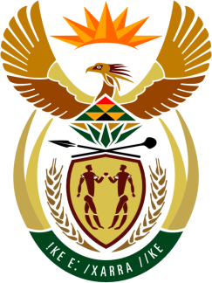

SOUTH AFRICAN PERMANENT MISSION
TO THE UNITED NATIONS
AND OTHER INTERNATIONAL ORGANISATIONS

42ND SESSION OF THE WORKING GROUP ON THE
UNIVERSAL PERIODIC REVIEW

Review of CZECHIA

23 JANUARY 2023

(70 Seconds)

speaker no: 25

Check against delivery

Mr. President,

South Africa welcomes the distinguished delegation of Czechia to this UPR Session and wishes the country a successful review.

Given the indivisibility of all human rights, South Africa commends Czechia on the second implementation plan of the Strategic Framework 2030, defining the country’s long-term sustainable development priorities to improve the quality of life of its people.

South Africa wishes to make the following recommendations:

- Expand the mandate of the Ombudsperson to take up the role of a national human rights institution in full compliance with the Paris Principles.
- Set specific targets and time frames to ensure an increase in the participation of women, including Roma women, in legislative assemblies, the executive and the public administration.
- Collect gender-disaggregated data on the inclusion of Roma in the education, employment, housing and health sectors in order to evaluate the effectiveness of existing measures.
- Explicitly prohibit corporal punishment against children and strengthen activities aimed at encouraging non-violent forms of discipline as alternatives in this regard.

I thank you

