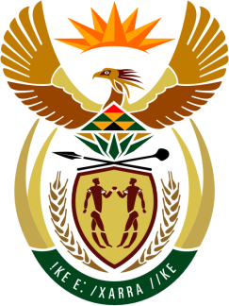

SOUTH AFRICAN PERMANENT MISSION

40th SESSION OF THE WORKING GROUP ON THE
UNIVERSAL PERIODIC REVIEW

Review of BENIN

26 JANUARY 2023
(09:00-12:00)

PALAIS DES NATIONS

Check against delivery

Mister President,

South Africa welcomes the distinguished delegation of Benin to this UPR Session.

My delegation is encouraged by reforms initiated by the Government of Benin that are aimed at consolidating the general legal framework and respect for human rights which include the abolition of the death penalty and the adoption of special procedures to punish gender-based offences.

In order to ensure progress in promoting and protecting human rights, South Africa wishes to respectively recommend that Benin:

- Continue efforts to fight stigma and discrimination of persons living with HIV, including persons from the LGBTQI+ community,

- Combat the sale of children for forced labour and implement the provisions of the Labour Code concerning child labour,

- Improve children’s access to social services,

- Strengthen the legal aid system to ensure effective access to justice for all persons involved in judicial proceedings.

South Africa wishes Benin a successful review.

I thank you.

