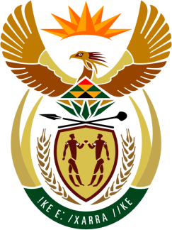

SOUTH AFRICAN PERMANENT MISSION
TO THE UNITED NATIONS
AND OTHER INTERNATIONAL ORGANISATIONS

42ND SESSION OF THE WORKING GROUP ON THE
UNIVERSAL PERIODIC REVIEW

ARGENTINA

23 JANUARY 2023

(70 Seconds)

speaker no: 12

Check against delivery

Mr. President,

South Africa welcomes the distinguished delegation of Argentina to this UPR Session and wishes the country a successful review.

South Africa commends Argentina on the landmark adoption of the Access to Voluntary Termination of Pregnancy Act. South Africa similarly welcomes the establishment of the Ministry for Women, Gender and Diversity, which together with the National Action Plan for Combatting Gender-Based Violence, demonstrates that gender is indeed at the centre of country’s policy agenda and will go a long way in addressing the remaining challenges, including femicide.

South Africa wishes to make the following recommendations:

- Approve the Comprehensive Bill Against Institutional Violence.
- Introduce early detection and reporting mechanisms for sexual violence and abuse by parents, relatives or caregivers, in close collaboration with role-players working on children’s rights.
- Appoint a National Ombudsman in compliance with the principles relating to the status of national institutions for the promotion and protection of human rights (the Paris Principles).
- Accelerate efforts to advance the needs and interests of people of African descent and implement policies for the promotion of their participation in the public sector and the advancement of all their rights.

I thank you

