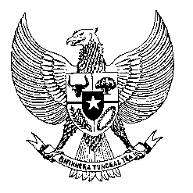

Permanent Mission
of the Republic of Indonesia to the UN, WTO,
and Other International Organizations
in Geneva

STATEMENT BY THE DELEGATION OF THE REPUBLIC OF INDONESIA
AT THE 42nd SESSION OF THE UPR WORKING GROUP
CONSIDERATION OF THE UPR REPORT OF SRI LANKA
JANUARY 2023

Thank you, Mr. President,

My delegation welcomes the delegation of Sri Lanka and thanks them for the presentation.

Indonesia recognizes Sri Lanka’s progress to promote women’s rights including incorporation of gender responsive budgeting for 2023.

In the spirit of constructive engagement, we would like to recommend the following:

First, take all necessary measures to create and implement economic policies that prioritize eradication of poverty throughout the country.

Second, continue efforts to protect the right of freedom of religion and beliefs for all persons in Sri Lanka including the religious practice and expression.

Third, strengthen efforts to protect and fulfil the right of adequate standard of living particularly for older persons and persons with disabilities.

We wish Sri Lanka every success in this review and its implementation.

Thank you.

