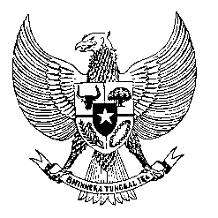

Permanent Mission
of the Republic of Indonesia to the UN, WTO,
and Other International Organizations
in Geneva

STATEMENT BY THE DELEGATION OF THE REPUBLIC OF INDONESIA
AT THE 42nd SESSION OF THE UPR WORKING GROUP
CONSIDERATION OF THE UPR REPORT OF JAPAN
31 JANUARY 2023

Thank you, Mr. President,

My delegation welcomes and thanks the delegation of Japan for the presentation.

We acknowledge measures by Japan to continue the promotion of human rights and welcomes Japan’s leadership in disaster prevention efforts.

With the spirit of constructive engagement, We recommend the following:

- Continue efforts to promote human rights education… particularly those aimed at eliminating gender stereotypes and bias in society.
- Strengthen efforts in the implementation of the right to work for women… and in creating favourable working conditions for them.
- Continue efforts to ensure the right to education for children of migrants, refugees and asylum seekers.

We wish Japan every success in this review and its implementation.

Thank you.
Time
^{.....st} speaker

