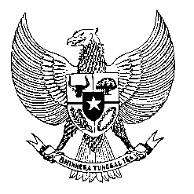

Permanent Mission
of the Republic of Indonesia to the UN, WTO,
and Other International Organizations
in Geneva

STATEMENT BY THE DELEGATION OF THE REPUBLIC OF INDONESIA
AT THE 42nd SESSION OF THE UPR WORKING GROUP
CONSIDERATION OF THE UPR REPORT OF ZAMBIA
30 January 2023

Thank you, Mr. President,

My delegation welcomes and thanks the delegation of Zambia for their presentation.

Indonesia recognizes Zambia’s efforts in aligning international human rights standards into national laws, including the banning of corporal punishment of children.

Indonesia offers the following recommendations:

- Consider ratifying the ICMW.

- Continue to take measures to prevent and combat trafficking in persons and provide necessary resources to support victims of trafficking to prevent revictimization.

- Continue to adopt and implement effective policies to ensure freedom of expression and of peaceful assembly, including for journalists and media.

- Enhance efforts to effectively eradicate gender-based violence.

We wish the Delegation of Zambia success in this review and its implementation.

Thank you.
Time
^{.....st} speaker
…words

