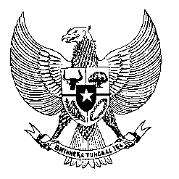

Permanent Mission
of the Republic of Indonesia to the UN, WTO,
and Other International Organizations
in Geneva

STATEMENT BY THE DELEGATION OF THE REPUBLIC OF INDONESIA
AT THE 42nd SESSION OF THE UPR WORKING GROUP
CONSIDERATION OF THE UPR REPORT OF SWIZERLAND
27 JANUARY 2023

Mr. President,

My delegation welcomes and thanks the delegation of Switzerland for the presentation.

We recognize the adoption of the Equality Strategy 2030 which includes measures to strengthen women’s economic empowerment and reduce domestic violence against women.

Indonesia offers the following recommendations:

- Reconsider ratifying the ICMW.

- Take necessary measures to strengthen protection against all forms of racism, discrimination, xenophobia, and Islamophobia including through consultations with all affected groups.

- Adopt comprehensive policies to reduce the gender pay gap between women and men, and promote better representation of women in key roles.

- Develop comprehensive federal and cantonal frameworks for inclusive education for all children with disabilities to ensure their full enjoyment of the right to education.

We wish the Delegation of Switzerland a successful review.

Thank you.
Time: 1:00
30th speaker

