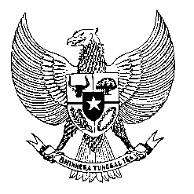

Permanent Mission
of the Republic of Indonesia to the UN, WTO,
and Other International Organizations
in Geneva

STATEMENT BY THE DELEGATION OF THE REPUBLIC OF INDONESIA
AT THE 42nd SESSION OF THE UPR WORKING GROUP
CONSIDERATION OF THE UPR REPORT OF THE REPUBLIC OF KOREA
26 JANUARY 2023

Thank you, Mr. President,

My delegation warmly welcomes the delegation of the Republic of Korea and thank them for the presentation.

Indonesia acknowledges measures and progress in human rights promotion and protection in the country including in the area of military service and women empowerment through the Gender Equality Basic Plan.

With the spirit of constructive engagement, Indonesia offers the following recommendations:
- Carry out national deliberation among relevant institutions and stakeholders on the possibility of ratification of the ICMW.
- Continue efforts to address gender-based crimes and discrimination against women particularly in the employment sector including by creating conducive working environment for women.
- Take all necessary measures to effectively ensure labour protection for all workers.

We wish the Republic of Korea every success in this review and its implementation.

Thank you.
Time
^{.....st} speaker

