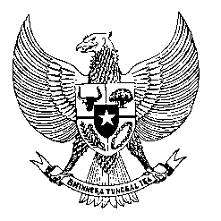

Permanent Mission
of the Republic of Indonesia to the UN, WTO,
and Other International Organizations
in Geneva

Statement
by the Delegation of the Republic of Indonesia
at the 42nd Session of the UPR Working Group
Consideration of the UPR Report of Benin
26 January 2023

President,

Indonesia welcomes the delegation of Benin and thanks them for their presentation.

We congratulate Benin for the establishment of the Benin Human Rights Commission in 2019, as well as the legal reforms that Benin has undertaken.

To further improve human rights in Benin, Indonesia offers the following recommendations:

- Continue efforts to address malnutrition with a view to reduce infant, neonatal and maternal mortality rates;

- Take further steps to guarantee unimpeded access to education for all women and girls both in rural and urban areas; and

- Strengthen efforts to ensure the right to due process of law;
Indonesia wishes the delegation of Benin a successful review.

I thank you.

(Max: …)

