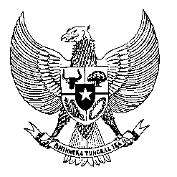

Permanent Mission
of the Republic of Indonesia to the UN, WTO,
and Other International Organizations
in Geneva

Statement
by the Delegation of the Republic of Indonesia
at the 42nd Session of the UPR Working Group
Consideration of the UPR Report of Guatemala
25 January 2023

President,

Indonesia welcomes and thanks the delegation of Guatemala for their presentation.

We commend the establishment of the Presidential Commission for Peace and Human Rights 2020 to ensure the effective enjoyment and protection of human rights of its people.

To further improve human rights in Guatemala, We recommend the following:

- Continue efforts to combat corruption, including in the judicial system;

- Continue to strengthen measures to combat violence against women and children;

- Enhance women’s access to decent work with a view to end discrimination against women; and

- Enhance efforts in combatting human trafficking, exploitation of persons and other contemporary forms of slavery.
Indonesia wishes Guatemala a successful review.

I thank you.

(Max: …)

