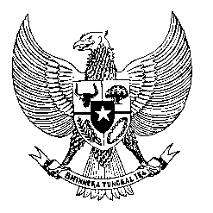

Permanent Mission
of the Republic of Indonesia to the UN, WTO,
and Other International Organizations
in Geneva

Statement
by the Delegation of the Republic of Indonesia
at the 42nd Session of the UPR Working Group
Consideration of the UPR Report of Peru
25 January 2023

President,

Indonesia thanks the delegation of Peru for their presentation.

We welcome Peru’s adoption of its first National Action Plan on Business and Human Rights.

To further improve human rights in Peru, Indonesia offers the following recommendations:

- Strengthen preventive measures… to more effectively combat femicide and violence against women;

- Further ensure the right to vote for persons with disabilities… in particular those who are previously under guardianship; and

- Continue to take measures to promote democracy and the rule of law, including in tackling corruption.

Indonesia wishes Peru a successful review.

I thank you.

(Max: …)

