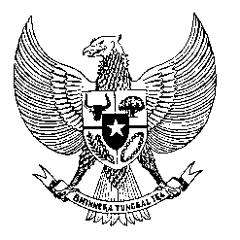

Permanent Mission
of the Republic of Indonesia to the UN, WTO,
and Other International Organizations
in Geneva

Statement
by the Delegation of the Republic of Indonesia
at the 42nd Session of the UPR Working Group
Consideration of the UPR Report of Ghana
24 January 2023

President,

Indonesia welcomes the delegation of Ghana and thanks them for their presentation.

We commend Ghana for its extensive efforts in combatting poverty and improving access to healthcare, among others through its Livelihood Empowerment Against Poverty program.

To further improve human rights in Ghana, Indonesia offers the recommendations:

- Take further measures to improve maternal healthcare services in public health facilities;
- Take further steps in addressing the issue of prison overcrowding; and
- Consider developing a national action plan on human rights, including in the business sector;
Indonesia wishes the delegation of Ghana a successful review.

I thank you.

(Max: …)

