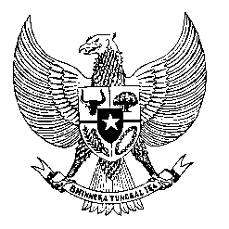

Permanent Mission
of the Republic of Indonesia to the UN, WTO,
and Other International Organizations
in Geneva

Statement
by the Delegation of the Republic of Indonesia
at the 42nd Session of the UPR Working Group
Consideration of the UPR Report of Gabon
24 January 2023

President,

Indonesia welcomes the delegation of Gabon and thanks them for their presentation.

We welcome Gabon’s enactment of a number of laws and regulations designed to promote and protect human rights, since its last review.

To further improve human rights in Gabon, Indonesia offers the following recommendations:

- Strengthen efforts to promote the right to freedom of expression and of peaceful assembly,

- Continue efforts to combat child trafficking, and

- Accelerate the process to operationalize the National Human Rights Commission in line with the Paris Principles.

Indonesia wishes the delegation of Gabon a successful review.

I thank you.

(Max: …)

