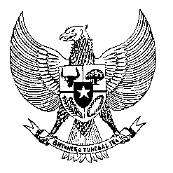

Permanent Mission
of the Republic of Indonesia to the UN, WTO,
and Other International Organizations
in Geneva

STATEMENT BY THE DELEGATION OF THE REPUBLIC OF INDONESIA
AT THE 42nd SESSION OF THE UPR WORKING GROUP
CONSIDERATION OF THE UPR REPORT OF ARGENTINA
23 JANUARY 2023

Thank you, Mr. President,

My delegation thanks the delegation of Argentina for their presentation.

Indonesia welcomes measures that have been carried out by Argentina to continue improving the rights of women including through providing higher investment for gender equality policies.

With the spirit of constructive engagement, Indonesia offers the following recommendations:

First, to better incorporate human rights principles in designing economic policies in order to eradicate poverty and improve living conditions for all people in Argentina.

Second, to enhance measures to combat hate speech and discrimination based on any grounds.

Third, to ensure effective implementation of the National Action Plan for Combating Gender-Based Violence and provide support for victims of violence.

We wish the Delegation of Argentina success in this review and its implementation.

Thank you.

