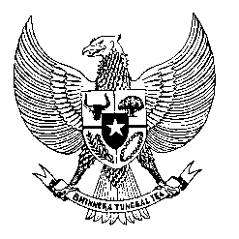

Permanent Mission
of the Republic of Indonesia to the UN, WTO,
and Other International Organizations
in Geneva

Statement
by the Delegation of the Republic of Indonesia
at the 42nd Session of the UPR Working Group
Consideration of the UPR Report of Czechia
23 January 2023

President,

Indonesia thanks the delegation of Czechia for their report.

We commend Czechia’s on-going efforts in implementating previous recommendations.

To further improve human rights in Czechia, Indonesia offers the following recommendations:

- Take further steps to establish the Ombudsman as a National Human Rights Institution according to the Paris Principles.

- Endorse and implement the United Nations Compact for Safe, Orderly and Regular Migration;

- Provide adequate protection to refugees and asylum seekers without discrimination; and

- Further promote policies and programs to counter discrimination and hate speech, including Islamophobia.

Indonesia wishes the delegation of Czechia a successful review.

I thank you.

(Max: …)

