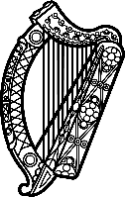

Statement of Ireland
42nd session of the UPR Working Group

Review of Switzerland

27th January 2023

Ireland warmly welcomes the delegation of Switzerland and thanks it for its presentation today. We commend Switzerland’s concerted efforts to advance human rights domestically, as reflected in the progress made since the last UPR cycle.

Ireland welcomes the September 2021 amendment to the Civil Code, which came into effect in July 2022, and granted same-sex couples the right to marry, and the same institutional and legal status as opposite-sex couples, including in relation to adoption.

Ireland recommends Switzerland:
- Introduce a general anti-discrimination law that is uniformly enforceable throughout the Confederation and which includes clear prohibition of racial discrimination.
- Address the lack of mandate to receive individual complaints in the national human rights institute, and ensure adequate funding for the institute.

We wish Switzerland every success in this UPR cycle. Thank you.

