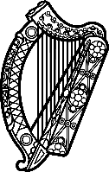

Statement of Ireland
42 session of the UPR Working Group

Review of Czechia

23 January 2023

Ireland welcomes the delegation of Czechia and thanks it for its presentation today.

Ireland notes Czechia’s efforts to advance human rights domestically and notes progress made since the last UPR cycle, including the adoption of the Roma Equality, Inclusion and Participation Strategies (Roma integration strategy) 2021–2030 and encourage further progress to combat discrimination against Roma communities. Ireland regrets that a national human rights institution has not yet been established.

Ireland recommends Czechia:
- Strengthen the office of the Public Defender of Rights to undertake the role of National Human Rights Institution and ensure its mandate is in full compliance with the Paris Principles.
- Ratify the Council of Europe Istanbul Convention on the preventing and combatting violence against women and domestic violence.

We wish Czechia every success in this UPR cycle. Thank you.

