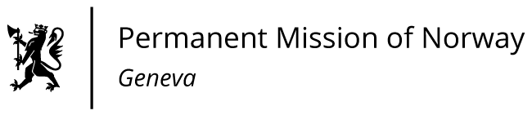

STATEMENT

42nd UPR Session of the Human Rights Council

on the human rights situation in Republic of Korea,

as delivered by Ms Anniken ENERSEN

Minister Counsellor, Human Rights

Check against delivery
26 January 2023

President,

Norway commends the Republic of Korea for the important progress made in protecting human rights and welcomes the improved enforcement of the Single Parent Family Support Act.
Norway also welcomes the enactment and implementation of the Framework Act on Prevention of Violence against Women.

Norway recommends that the Republic of Korea:

1) adopts comprehensive anti-discrimination legislation that prohibits discrimination of LGBTQI persons and other marginalised groups;

2) implements measures to ensure women’s equal participation in work life and politics, by preventing discrimination and reducing the gender wage gap;

3) takes steps towards the formal abolition of the death penalty, based on the longstanding moratorium.

Thank you.

